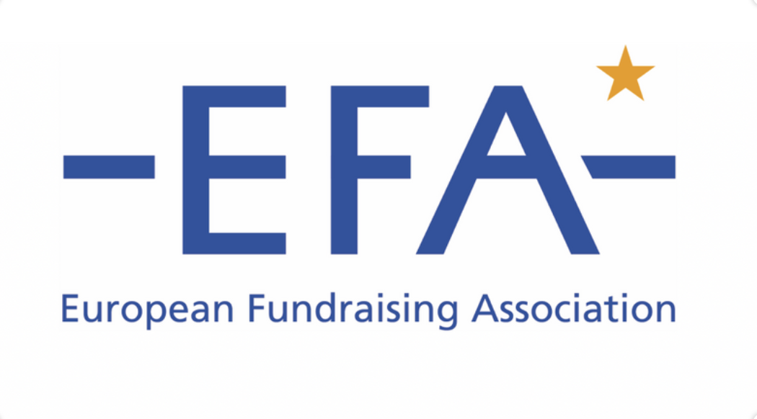
TEMPLATE MATERIALS FOR EFA MEMBERS

Welcome to our template materials pack designed to helped you encourage members / network to take part in this year’s COVID-19 survey.

These resources aim to help save you time in sharing this news with your members and others – we hope they will be useful. The wording is not prescriptive and, of course, many of you will want to promote it in your own way and translate this into the relevant language.

Thank you for your support.

This pack contains:
- Sample text for EFA members to send to their network
- Sample text for email newsletter copy
- Sample social posts
- Survey image
- Survey links

If you have any queries about the promotional resources, please email:
news@efa-net.eu.

TEMPLATE EMAIL COPY:

Draft text for EFA members to send to their network

Dear {XX},

Can you spare 5 minutes to contribute to a European survey on how Covid-19 continues to impact nonprofits?

With the global pandemic continuing to impact nonprofits, the European Fundraising Association and Salesforce.org are coming together once more to launch a short survey exploring the changes to fundraising and service delivery.

This project follows a similar survey carried out in 2020, which drew together insight from 800 respondents. The survey found that two thirds of respondents had to cancel fundraising activities and just under half struggled to reach beneficiaries or deliver services in lockdown.

This year’s survey is exploring the current landscape, what’s changing and how nonprofits are responding.

If you represent a nonprofit organisation, please share your insights by taking part today. The survey is likely to take you around 5 minutes and it can be completed in English, Dutch, French, German, Italian or Spanish.

Take survey

Many thanks…

TEMPLATE NEWS ITEM

Fundraisers and Nonprofit Leaders Urged To Participate in Covid-19 Survey
With the global pandemic continuing to impact nonprofits, the European Fundraising Association and Salesforce.org are coming together once more to launch a short survey exploring the changes to fundraising and service delivery.
Following a similar study carried out in 2020, this survey aims to gather insights from fundraisers and nonprofit leaders across Europe, building a picture of the current challenges and how organisations are adapting.
Eduard Marček, EFA President says: “Although we’re all much more accustomed to living and working in a global pandemic than we were this time last year, the nonprofit environment is just as challenging for many, if not more so. By collating insights from across Europe, we hope to build a clearer understanding of the current situation and, ultimately, ensure that we can support the sector in the years ahead.”
{Add quote from EFA member encouraging people to participate}.

The survey is available in English, Dutch, French, German, Italian or Spanish and takes around 5 minutes to complete.

Take Survey

TEMPLATE SOCIAL POSTS

Template LinkedIn Posts
Sample post 1
A new survey has been launched by the European Fundraising Association and Salesforce.org. Can you spare 5 minutes to help build understanding of the continued impact of Covid-19 on nonprofits? Take the survey here:
https://www.surveymonkey.co.uk/r/E_Covid_Pulse_2021

#NonprofitPulse #Covid19 #ngos #nonprofits #charities #fundraising #beneficiaries
#donorcare #supporterengagement #europe #pandemic #europeanfundraisingassociation

Sample post 2
One for nonprofit leaders and fundraisers in Europe! Can you spare 5 minutes to contribute to this survey from the European Fundraising Association and Salesforce.org? The survey aims to build a picture of the continued impact of Covid-19 on nonprofits across Europe. https://www.surveymonkey.co.uk/r/E_Covid_Pulse_2021

#NonprofitPulse #Covid19 #ngos #nonprofits #charities #fundraising #beneficiaries
#donorcare #supporterengagement #europe #pandemic #europeanfundraisingassociation

Sample post 3
In 2020, insight from fundraisers and others showed that the pandemic was heavily restricting fundraising activities, but that nonprofits were innovating and adapting. Can you help build a picture of what’s happening now?

Take the 5 minute survey here: https://www.surveymonkey.co.uk/r/E_Covid_Pulse_2021 #NonprofitPulse @EFAFundAssn @Salesforce.org

#NonprofitPulse #Covid19 #ngos #nonprofits #charities #fundraising #beneficiaries
#donorcare #supporterengagement #europe #pandemic

Template Facebook Posts
Sample post 1
One for nonprofit leaders and fundraisers in Europe! Can you spare 5 minutes to contribute to this survey from the European Fundraising Association and Salesforce.org? The multilingual survey aims to build a picture of the continued impact of Covid-19 on nonprofits across Europe. @EFAfanpage #NonprofitPulse
Take part of share here. https://www.surveymonkey.co.uk/r/E_Covid_Pulse_2021

Sample post 2
In 2020, insight from fundraisers and others showed that the pandemic was heavily restricting fundraising activities, but also that nonprofits were innovating and adapting. Can you help build a picture of what’s happening now?

Take the 5 minute survey here: https://www.surveymonkey.co.uk/r/E_Covid_Pulse_2021 #NonprofitPulse @EFAfanpage

Template Twitter Posts
Sample post 1
A new survey has been launched by @EFAFundAssn and @Salesforce.org to build understanding of the continued impact of Covid-19 on nonprofits. Can you spare 5 minutes to share your views? Take the survey here: https://www.surveymonkey.co.uk/r/E_Covid_Pulse_2021 #NonprofitPulse

Sample post 2
Calling nonprofit leaders and fundraisers in Europe! Can you spare 5 minutes to help build understanding of the continued impact of Covid-19 on #nonprofits across Europe? https://www.surveymonkey.co.uk/r/E_Covid_Pulse_2021 @EFAFundAssn @Salesforce.org #NonprofitPulse

Sample post 3
One for fundraisers, charity and NGO leaders in Europe! Can you spare 5 minutes to share your experience of the continued impact of the pandemic on nonprofits? @EFAFundAssn and @Salesforce.org are working together to collate views across Europe with this short survey. Take part here: https://www.surveymonkey.co.uk/r/E_Covid_Pulse_2021 #NonprofitPulse

Sample post 4
In 2020, insight from fundraisers and others showed that the pandemic was heavily restricting fundraising activities, but that nonprofits were innovating and adapting. Can you help build a picture of what’s happening now? Take the 5 minute survey here: https://www.surveymonkey.co.uk/r/E_Covid_Pulse_2021 #NonprofitPulse @EFAFundAssn @Salesforce.org

SURVEY HEADER IMAGE:

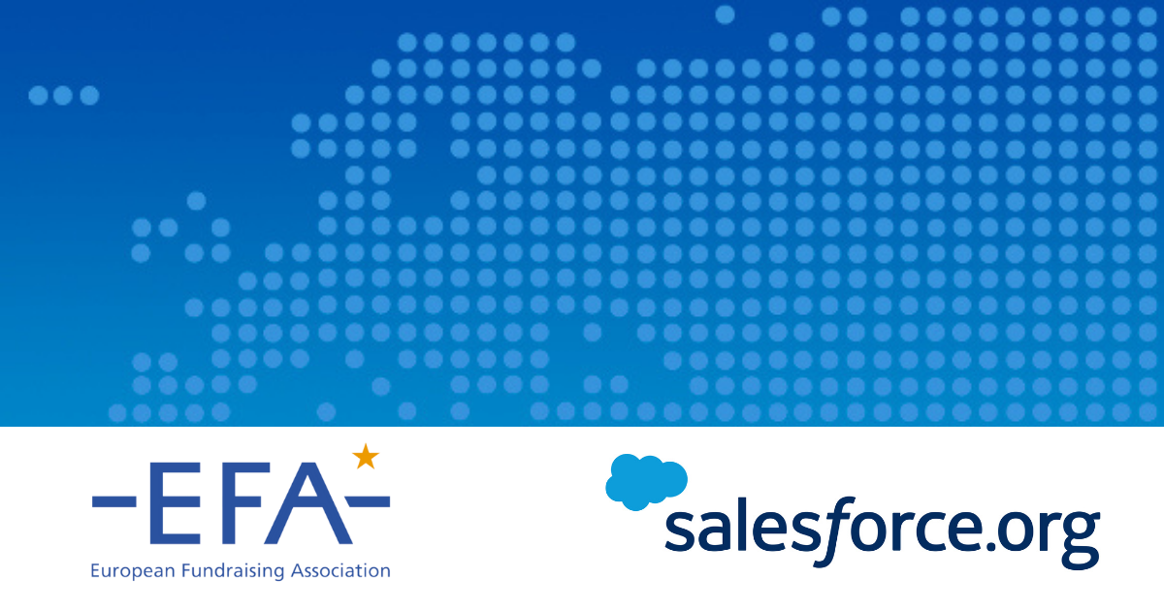

Other suitable images could include:
- Europe on the globe: https://unsplash.com/photos/7dEyTJ7-8os
- B/W Europe globe image: https://unsplash.com/photos/TH7TW20de9s

SURVEY LINKS:

Survey Link: https://www.surveymonkey.co.uk/r/E_Covid_Pulse_2021
The survey defaults to English, but can be completed in any of the languages below from the above link or via the direct language links below:
Dutch: https://www.surveymonkey.co.uk/r/E_Covid_Pulse_2021?lang=nl
French: https://www.surveymonkey.co.uk/r/E_Covid_Pulse_2021?lang=fr
German: https://www.surveymonkey.co.uk/r/E_Covid_Pulse_2021?lang=de
Italian: https://www.surveymonkey.co.uk/r/E_Covid_Pulse_2021?lang=it
Spanish: https://www.surveymonkey.co.uk/r/E_Covid_Pulse_2021?lang=es

